### Scenario

The local government authorities approach you to manage the construction of a community hall, as well as complete the internal decorations of the new hall. They require its completion within 10 months, the end of November, to coincide with Holiday events celebrated in this hall.

They are willing to support you in any means as they want the building ready within the outlined timeline. They are requesting you to provide them a floor plan and project plan document. Both of these documents will include all the construction activities and details regarding the interior finish.

As a Project Manager, you have decided to prepare a high-level design, and progressively elaborate through iterative feedback with the stakeholders. Once the design is finalized with them, you want to start the construction work using plan-driven methods.

Using the 49 step process chart, complete the following activity.

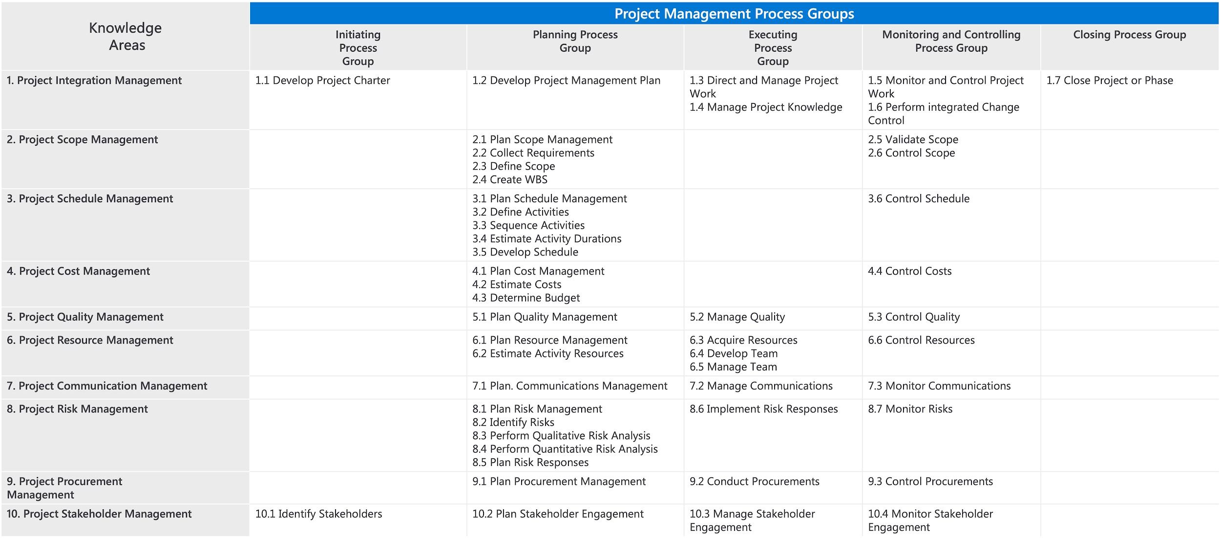

### Step 1: Identify the development approaches in this project.

From the given scenario, try to identify the development approaches you, the project manager, have decided to apply.

Match the correct development approach to the given scope.

1) Interior design scope 2) Construction scope 3) Overall project

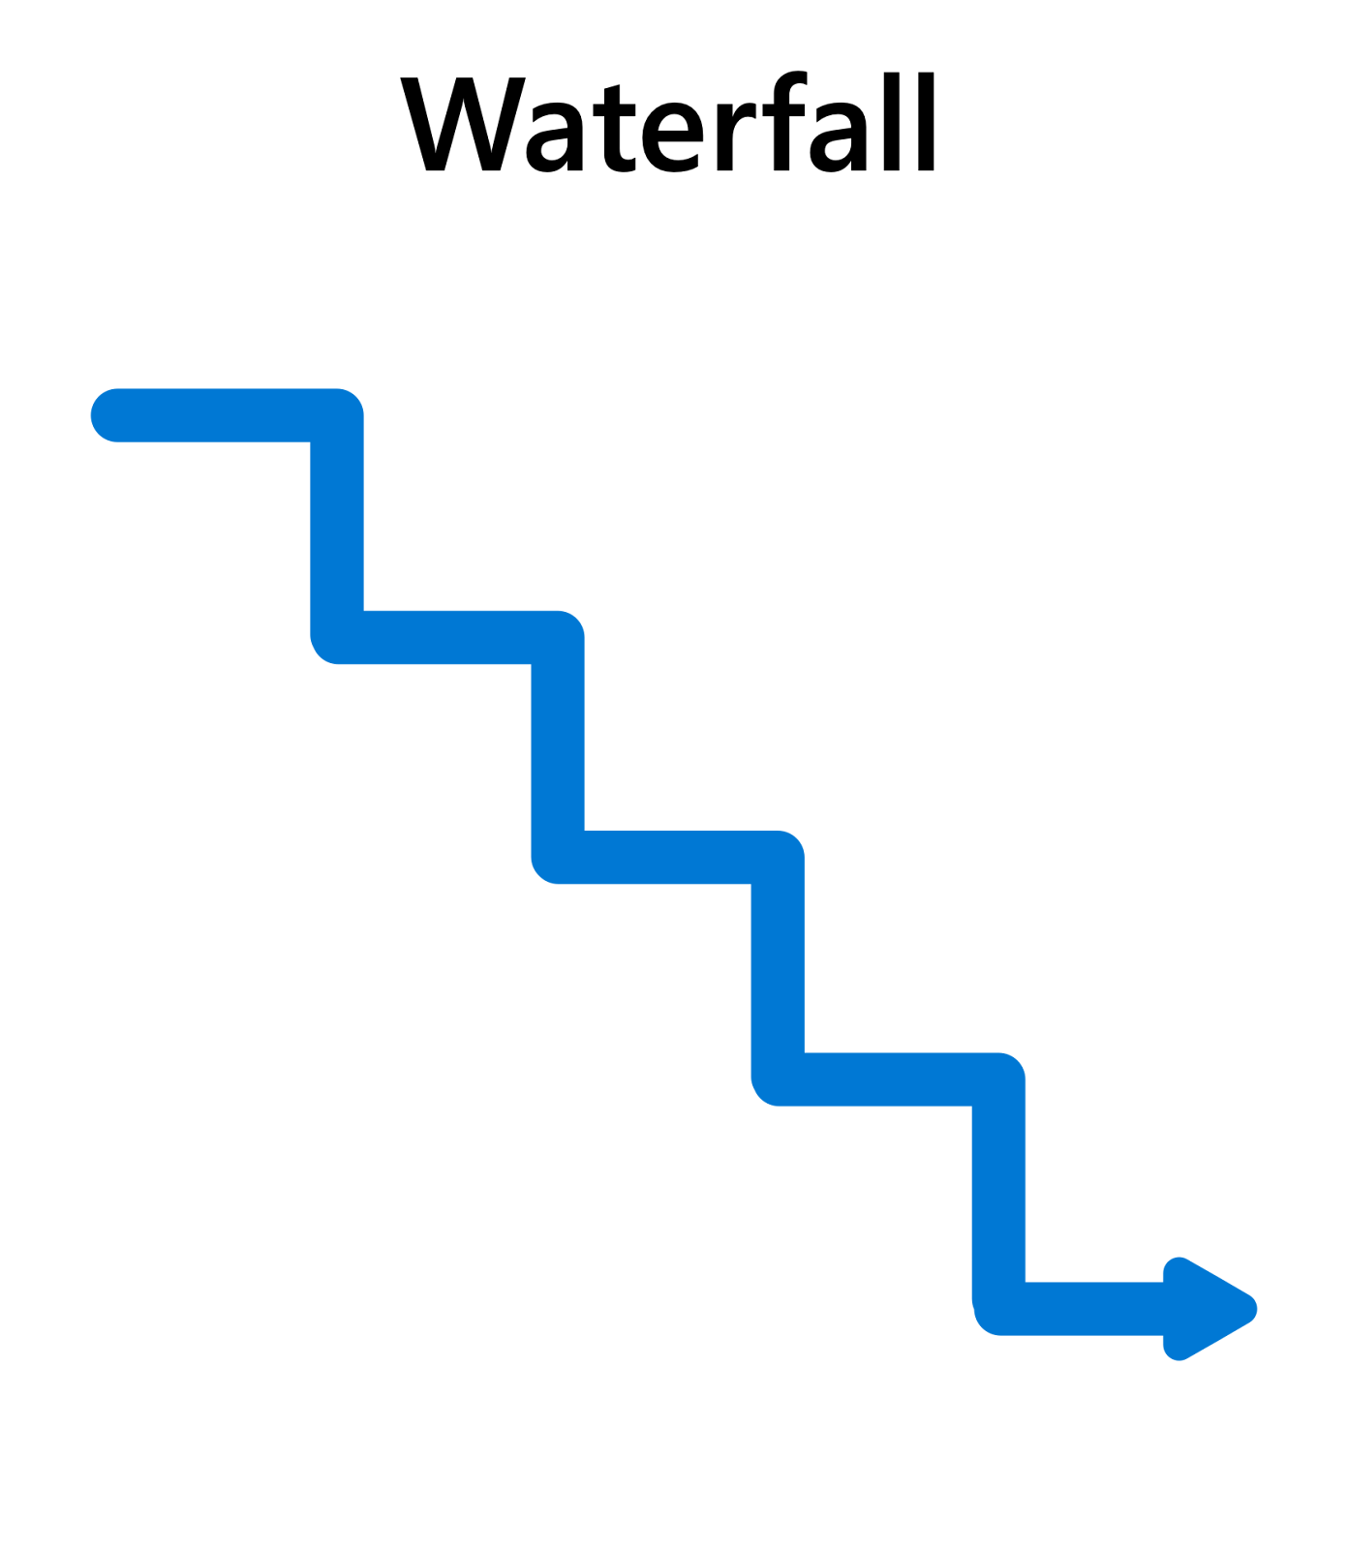 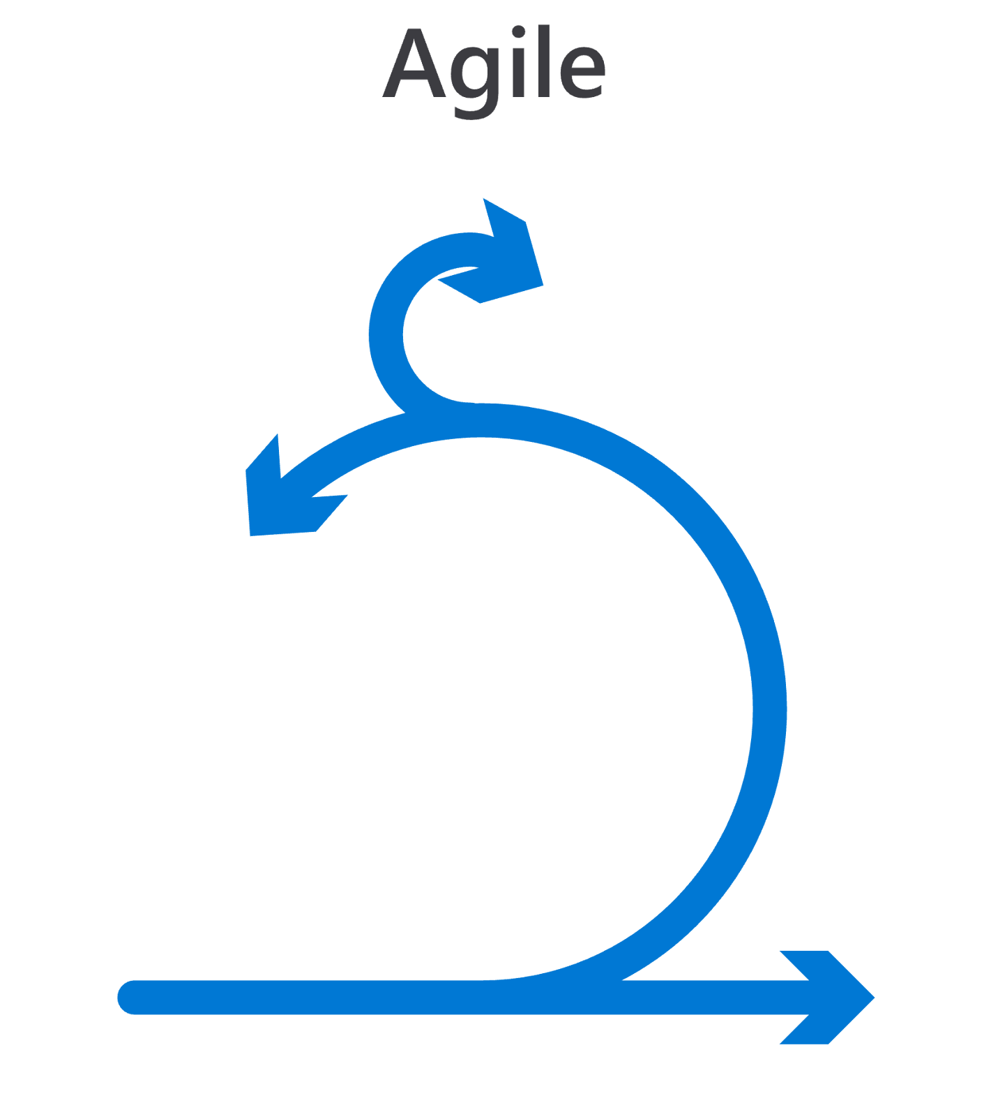

### Step 2: Elaborate the development approaches.

In what way will the identified development approaches be applied for product development in the project?

Development Approach 1 for Design Scope __________________________________________________________________________________________________________________________________________________________________________________________________________________________________________________________________________________________________________________

Development Approach 2 for Construction Scope

__________________________________________________________________________________________________________________________________________________________________________________________________________________________________________________________________________________________________________________

Development Approach 3 for Overall Project work

__________________________________________________________________________________________________________________________________________________________________________________________________________________________________________________________________________________________________________________

### Step 3: Select the knowledge areas suitable for this project.

Open the 49 Process chart for reference.

By analyzing the process chart, try to identify the various knowledge areas that may be applicable for this project overall.





### 

### Step 4: Justify your selection of knowledge areas with reasons.

Justify your selection of knowledge areas pertaining to this project.

____________________________________________________________________________________________________________________________________________________________________________________________________________________________________________________________________________________________________________________________________________________________________________________________________________________________________________________________________________________________________________________________________________________________________________________________________________________________________________________________________________________________________________________________________________________________________________________________________________________________________________________________________________________________________________________________________________________________________________________________________________________________________________

### Step 5: Select the project management processes suitable for this project and list them.

Open the 49 Process chart as reference.

By looking at the processes spread across the 10 knowledge areas and the 5 process groups in the process chart, identify the various processes that may be applicable for this project and list them.

------------------------------------------- -------------------------------------------- ----------------------------------------

------------------------------------------- -------------------------------------------- ----------------------------------------

------------------------------------------- -------------------------------------------- ----------------------------------------

------------------------------------------- -------------------------------------------- ----------------------------------------

------------------------------------------- -------------------------------------------- ----------------------------------------

------------------------------------------- -------------------------------------------- ----------------------------------------

------------------------------------------- -------------------------------------------- ----------------------------------------

------------------------------------------- -------------------------------------------- ----------------------------------------

------------------------------------------- -------------------------------------------- ----------------------------------------

------------------------------------------- -------------------------------------------- ----------------------------------------

### Step 6: Justify your selection of processes.

Justify your selection of processes pertaining to this project.

____________________________________________________________________________________________________________________________________________________________________________________________________________________________________________________________________________________________________________________________________________________________________________________________________________________________________________________________________________________________________________________________________________________________________________________________________________________________________________________________________________________________________________________________________________________________________________________________________________________________________________________________________________________________________________________________________________________________________________________________________________________________________________________________________________________________________________________________________________________________________________________________________________________________________________________________________________________________________________________________________________________________________________________________________________________________________________________________________________________________________________________________________________________________________________________________________________________________________________________________________________________________________________________________________________________________________________________________________________________________________________________________________________________________________________________________________________________________________________________________________________________________________________________________________________________________________________________________________________________________________________________________________________________________________________________________________________________________________________________________________________________________________________________________________________________________________________________________________________________________________________________________________________________________________________________________________________________________________________